**OTSAW Digital Frontend Developer – Interview Questions**

Q: What are data- attributes good for?  
  
**Ans:** An attribute defines a property of an object and it is good for storing custom data private to the application

Q: Why is it generally a good idea to position CSS <link> between <head></head> and JS <script> just before </body>? Do you know any exceptions?  
  
**CSS Link:** Browsers will need to reflow the layout as the CSS files load if the CSS link is not placed in the head tag.

**JavaScript:** JS scripts are best to be placed right before the body tag as it allows the display of the entire HTML above the script tag while it is processing the JavaScript.

Q: What is the difference between classes and IDs in CSS?  
  
**Ans:** Classes can be used multiple of times in the HTML code while IDs are unique variables and can only be used once.

Q: Describe Floats and how they work.

**Ans:** Floats are block-level elements that behave like an inline element. They do not exist on a line of their own. When floats are used, the rest of the content will just flow around the floated element. Floats allow an element to appear uniquely, independently. Normally, elements will be floated to the right or left.   
  
How it works:  
img {

    float: right;

    margin: 0 0 10px 10px;

}

Q: Explain CSS sprites, and how you would implement them on a page or site

**Ans:** CSS Sprites refers to a collection of images placed into a single image. As web page might take a while to load multiple of server requests, using image sprites will help to reduce to save the bandwidth.

Implementation: It is especially good for navigation images. Instead of instantiating the navigation menu images individually, using image sprites works better. To use the single image, simple apply this: ("img_navsprites.gif"):

Q: What does * { box-sizing: border-box; } do? What are its advantages?

**Ans:** It tells the browser the sizing properties and specifies that the div element should have padding and border included in the element’s total width and height. It makes the codes neater and gives a more efficient workflow.

Q: Explain how ***this*** works in JavaScript  
  
**Ans:** The value ***this*** is used in a function of a JavaScript, which refers to the object that owns the function. However, ***this*** does not have any value, as it is an object constructor.

Q: When would you use ***document.write()***?

**Ans:** It is used to display content on a webpage. This function takes the content that you want to write as a parameter. It is best used when one is working for a third party such as ads, as they do not know the environment.

Q: What is ***"use strict";*** ? what are the advantages and disadvantages to using it?

**Ans:** This function tells that a JavaScript code should be executed in a strict mode. In strict mode, the use of undeclared variables is not allowed. Strict mode makes it easier to write a more secured Java Scripts. Issues such as typo in the codes will be easily identified with this strict mode being implemented, as only variables that have been declared would not give any error.

Q: Explain the differences on the usage of foo between function foo() {} and var foo = function() {}

**Ans:** Function foo() is an actual named function (function declaration) while variable foo() is a regular variable declaration (function expression) with an anonymous function attached to it. Function declarations are evaluated upon entry into the closing scope while function expressions are evaluated as part of a step-by-step code.

Q: Convert the Admin Dashboard to template using HTML, CSS or using the following resources.

Template: <http://getbootstrap.com/>

Font: <http://fontawesome.io/>

(Time allowed 2 hours)

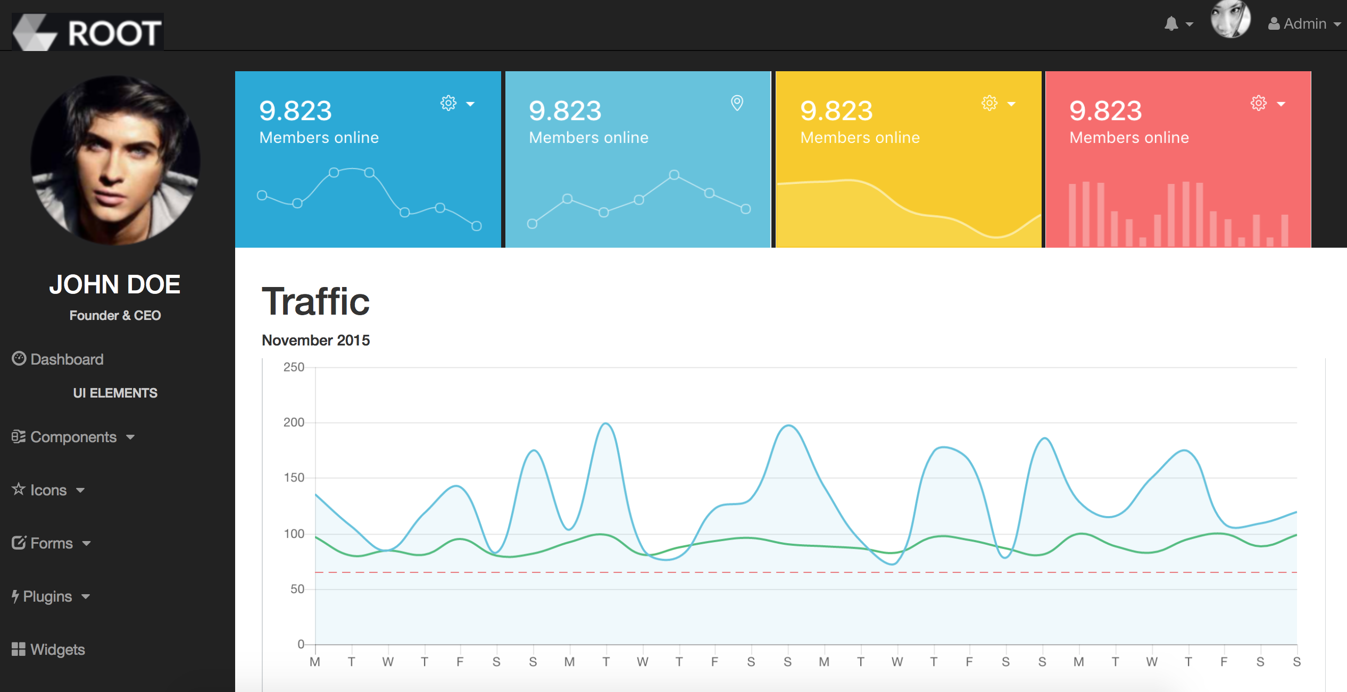

Please submit your source-code by Github or BitBucket.